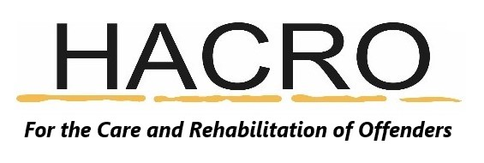NEWSLETTER July 2021
Achievement Awards 2021
HACRO is pleased to announce that we will be holding our 5th Achievement Awards. As in previous years, HACRO’s Achievement Awards celebrate the successes of offenders who have turned their lives around. Nominations are received from the police, probation services and other statutory and voluntary organisations. The greatest reward for them and their families is the accolade of the dignitaries present, but also the atmosphere of the evening.

This year’s ceremony will be held in the University of Hertfordshire’s Weston Auditorium on the 20^{th of} September 2021 at 6.30pm for a 7pm start. We are very much looking forwards to the event and celebrating the achievements of those that have shown great courage and determination to turn their lives around.

If you know and work with a service user that has shown determination and courage to turn their life around and have left reoffending behind them, please nominate them for an award. All nominees and their sponsors will be invited to attend the presentation event at the University of Hertfordshire on 20th of September. The event is being attended by the Lord Lieutenant and it is likely that the Chief Constable and Police and Crime Commissioner will also be there.
If you would like to nominate email office@hacro.org.uk or visit our website www.hacro.org.uk. The deadline for nominations is Monday 2nd August.
Our Project Updates
Growing Together pilot | Our couple’s relationship programme is due to start soon once we get the go ahead.
Step Forward | All mentors have at least 1 client and are supporting them with CV writing, searching for employment and interview techniques.
Confidential Support Scheme | HACRO launched this on the 13^{th of} June for staff and volunteers to share any concerns or issues surrounding work.
NPS – IOM | A mentor is working with a client on literacy skills and is proving invaluable to the client.
Volunteers | We are still recruiting volunteers for Step Forward, BBO and the Visitor Centre at HMP The Mount.
Visitor Centre | The Visitor Centre is still offering a reduced service, but visitors greatly appreciate our presence. We have just recruited 2 sessional staff members – we welcome them to HACRO.
Dedicated Dads | Dedicated Dads has just received it’s fourth lot of funding. The programme has deemed so popular that referrals keep coming in.
Small Grants | Since March we have received 59 small grant requests. Most of these are for photo ID or for furniture and essential household items. Small grants are reliant on donations.
WorkAbility | A WorkAbility pilot course is proceeding at HMP The Mount. A cookery book for the remote BBO cookery lessons has been approved. A 5th remote cookery course is in the planning stage and should start soon.
Caring Dads | The course continues to go well, with good levels of attendance and participation. The majority of participants have attended every session and are punctual.  Broxbourne 2021 Caring Dads started last Thursday and will run to 28th October.  Our next Caring Dads course will be in St Albans.
BBO | BBO has had 25 referrals since 1st June and  HACRO are in the process of recruiting a new mentor.  The activities are going well and BBO are seeing great participation and engagement by clients.

We had a lovely staff lunch earlier this month at The Fishery Inn. It was great to see everyone face to face for the first time in well over a year.
