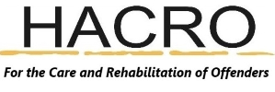
Newsletter June 2022
HACRO’s Afternoon Tea Event on Friday the 17^{th of} June 2022

Emmaus very kindly offered to allow HACRO to host an afternoon tea event in their beautiful, shady garden. Anyone that attended would know that the shade offered relief from the sun that day!
The event gave HACRO the opportunity to showcase the work that we do. We had a stand for each project, our family services, our work-readiness programmes and small grants. HACRO’s Trustees and staff were present to talk about their particular project and to learn about what our guests do too.
We had the real delight of BBO participants holding their studio session at Emmaus that day. The talents of the participants were fantastic – singing, playing the guitar and the drums. BBO also did a carpentry demonstration and gave guests the opportunity to see pieces that they had made and were in the process of making.
HACRO were honoured that guests attended from across Hertfordshire, ranging from the Lord Leuitenant Robert Voss, the High Sheriff that will be in post from 2023-2024 Liz Green, Mayors and Councillors and representatives from a range of organisations. It was a great opportunity for us to inform our guests about the work of HACRO but also to build relationships with key figures and organisations across Hertfordshire.
HACRO would like to thank everyone that attended and Emmaus for allowing us to hold our event at their premise. HACRO and Emmaus work in close partnership. HACRO are privileged to be able to use the facilities at Emmaus for certain activities and HACRO support members of the Emmaus community.
For information about Emmaus visit Emmaus Hertfordshire - Homelessness Charity Hertfordshire and to find out more about HACRO visit our website at www.hacro.org.uk

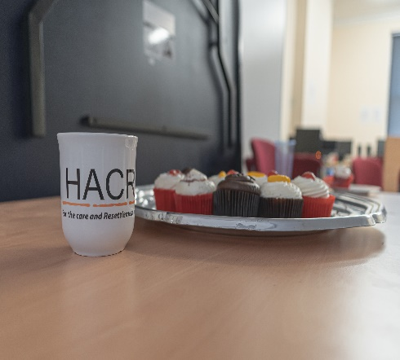 | 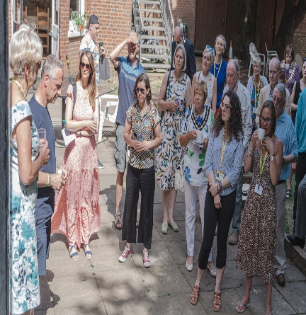 | 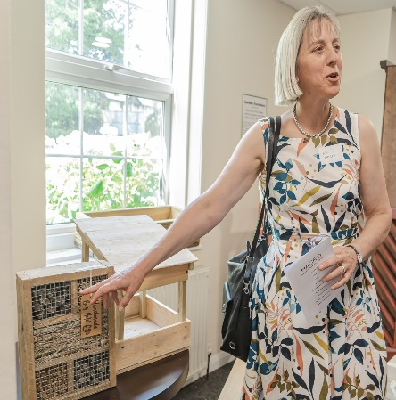
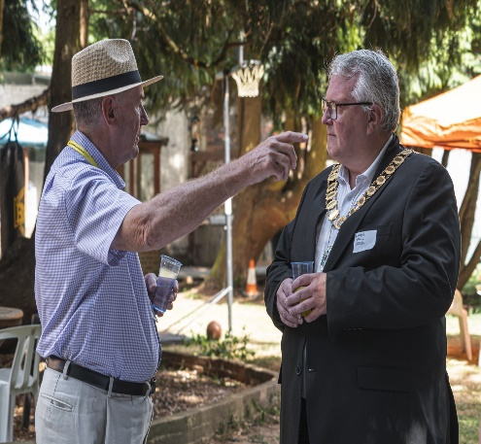 | 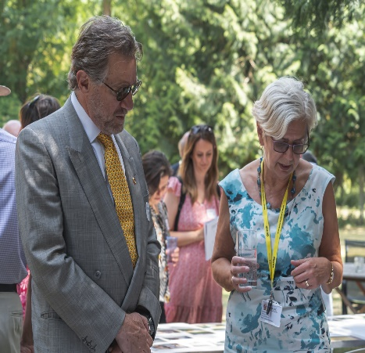
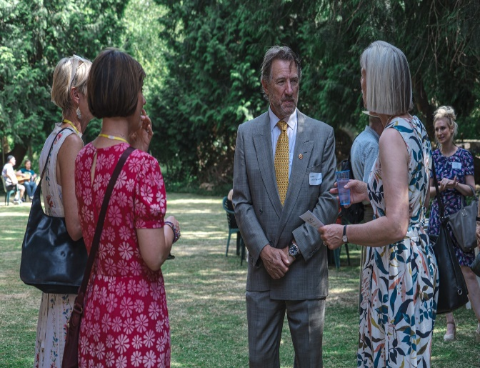 | 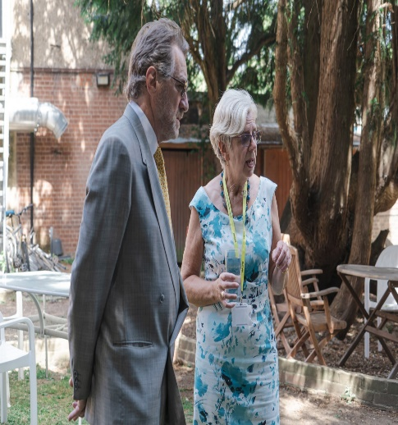 | 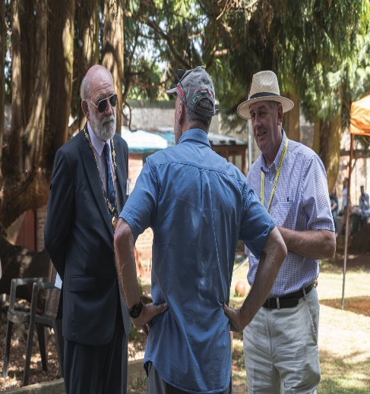
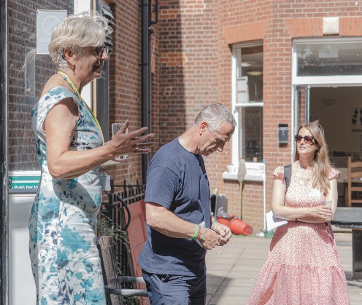 | 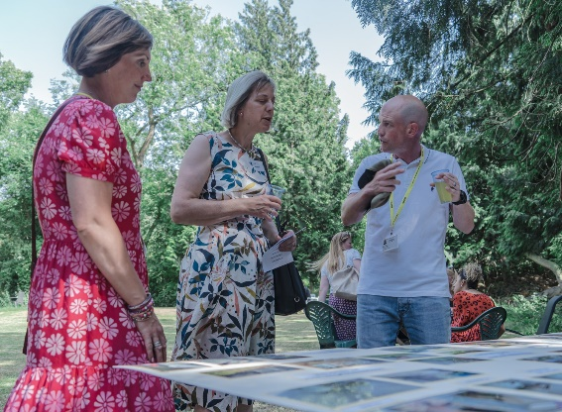 | 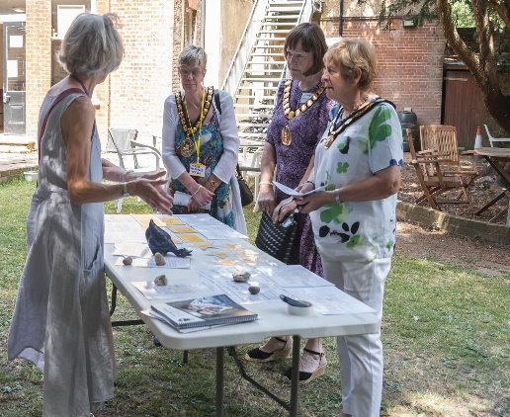
Thank you to everyone for supporting HACRO and the invaluable work that we do!

