HACRO NEWSLETTER – JANUARY 2022

We would like to wish you all a happy New Year!

HACRO had a successful 2021. Here are some of our highlights.

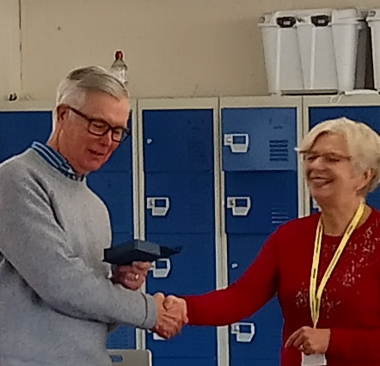  Congratulations to Trevor Jones -HACRO’s Volunteer of the Year 2021.  HACRO are truly grateful to all our volunteers for the time and dedication they give to HACRO and to our service users! | Trevor says “I have been volunteering at HACRO for a few years now both within the Prison and with ex-Offenders. People ask me why I do it. Sometimes it can be challenging and even frustrating, but I say it is always interesting. I have learnt a lot about how people can end up in prison and about their hopes for a better life. If I can help them find constructive ways to achieve that, then it is truly rewarding. I never forget those real “light bulb” moments.  To be named Volunteer of the Year came as a total shock to me, but an Award I was happy to accept. There are a lot of people at HACRO who work quietly in the background but who are making a real difference. I feel privileged to work alongside them.”
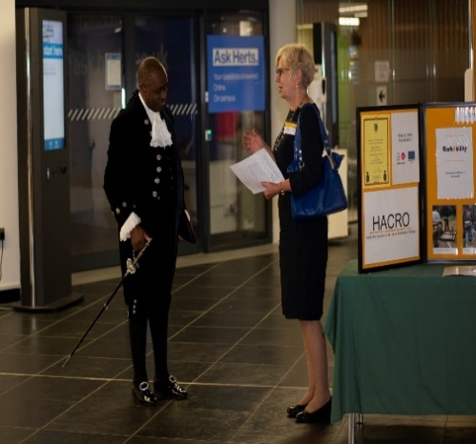  HACRO’s Achievement Awards in September celebrated the courage and determination of individuals that had turned their lives around. |  | - The Visitors Centre at The Mount has re-opened since April and although it is currently operating reduced hours, we anticipate it will be fully operational in the New Year. Louise Bandle has been managing the Visitors Centre alongside her admin role.  - Our BBO team was strengthened by appointing Tony Franklin as Team Leader and he now has three part time colleagues, Claire Neate, Emma Hooper and Karina Griffiths.
- WorkAbility was suspended throughout the Covid restrictions and was slow to restart due to limitations on groups in probation premises. However, we now have courses underway or planned at Broxbourne, St Albans and Stevenage probation offices, at Gateway Hostel and Druglink and inside HMP The Mount, thanks to the energy and commitment of our three tutors, Sara Johnson, Jo Perschky and Fin Lawrence.  - Step Forward, coordinated by Jo Perschky involves volunteer job mentors working 1:1 with offenders as they progress towards employment. This is in effect a wrap-around service for WorkAbility so that people have support before and after the course ends. |  | 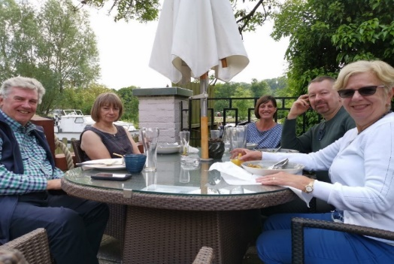  HACRO Trustees and Staff enjoyed lunch together at The Fishery Inn. This was HACRO’s first face to face event since lockdown. It was nice to see people in the flesh rather than on zoom.
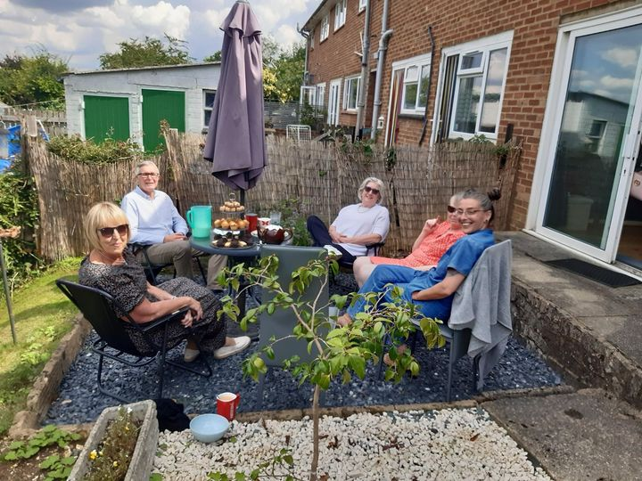  HACRO volunteers enjoyed afternoon tea in the summer. Tea, coffee, cakes and fun where had by all. |  | - Dedicated Dads was originally planned as a stopgap during restrictions until such time as Caring Dads could resume. However, because it is delivered via video call it provides a service to men who are unable to access a Caring Dads course due to shift work, geographical distance or because they can’t cope with groups, so it is now an established programme in its own right. We have secured funding for an independent evaluation of the programme by the University of Hertfordshire.
- Caring Dads courses have resumed, and one has been completed at Stevenage with  others under way or in planning. Joanna Emmerson, who organises the courses, has needed to find suitable venues to ensure social distancing for these face-to-face courses. We have recently heard that Hertfordshire County Council, who fund two courses/year will be continuing our contract for a further year. |  | HACRO’s staff away day in October. The morning consisted of training delivered by Probation and the afternoon team building activities. Lots of fun!  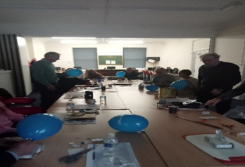
HACRO were pleased to announce in early 2021 that we got full accreditation by the Living Wage Foundation.  HACRO aims to ensure that all staff members are treated fairly and in line with current employment legislation. |  | - Since last year’s AGM we have submitted 11 bids for additional funding, and were successful 70% overall, bringing in a further £77,000 of income across projects. We recently submitted a substantial bid to HMPPS in partnership with the office of the Police and Crime Commissioner for Herts and the University of Hertfordshire. The outcome should be known in early January.

